Understand the problem

The CRM team would like to send email campaigns with next best brand recommendation to customers who are most likely to repurchase in the next 3 months. Build a model based on the given dataset and identify which customers can be targeted. If each email costs the company £2, what's the total misclassification cost?

Please present the results with key insights and appropriate evaluation metrics. The actual presentation should not exceed 30 minutes. Please send across your notebooks/github links, slides, excel etc. beforehand.

Understand the data: Variable Definition (17 columns, 101000 records or rows)

- customer_site_id (str) = Customer Identifier

- orders_1yr (int) = Number of orders placed in last 12 months

- line_items_1yr (int) = No. of items purchased in last 12 months

- days_since_last_purchase_1yr (int) = Days since last purchase inlast 12 months

- prop_reduced_items_1yr (float) = Proportion of reduced priced items bought in the last 12 months

- promo_customer_blc_1yr (int) = whether the customer used blue light promotion offer in the last 12 months (0, 1)

- promo_customer_freedelivery_1yr (int) = whether free delivery was offered to the customer in the last 12 months (0, 1)

- Brand_Nike_prop_revenue_1yr (float) = Proportion of revenue from Nike product purchases in the last 12 months

- Brand_Adidas_prop_revenue_1yr (float) = Proportion of revenue from Adidas product purchases in the last 12 months

- Device_mobile_prop_revenue_1yr (float) = Proportion of revenue from purchases on a mobile device in the last 12 months

- Device_iosapp_prop_revenue_1yr (float) = Proportion of revenue from purchases on a ios device in the last 12 months

- Delivery_NextDay_prop_revenue_1yr (float) = Proportion of revenue from purchases with Next Day Delivery in the last 12 months

- Payment_bnpl_prop_revenue_1yr (float) = whether the customer used bnpl ( buy now pay later) in the last 12 months

- amount_paid_per_order_1yr (float) = Total order amount before delivery

- Current_RFM_Segment (str) = RFM (Recency, Frequency, Monetary) segment of the customer

- ONS_Segment (str) = Socio-demographic segment fo the customer ( from ONS)

- repurchased (int) = Whether the customer made a repeat purchase in the next 3 months (0, 1)

Pre-processing and cleaning data (Remove missing data in the record and map some string columns to make it comparable with other features for model training)

Suggestion removes outlier for a better modelling step.

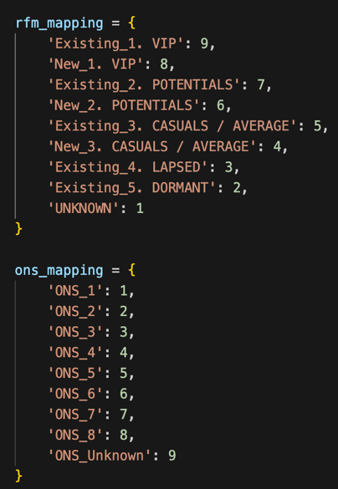
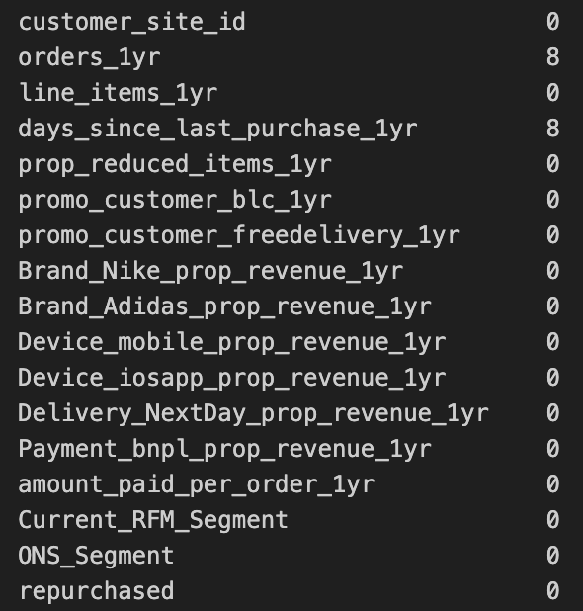

101000 -> 100992 = only 8 rows has been removed in the process
Reason:

- We chose to remove the missing values rather than filling them with the average or another number, as we have sufficient data, and imputation would introduce unnecessary and potentially misleading information

- We converted some string columns to categorical numbers to make them comparable with other features for model training

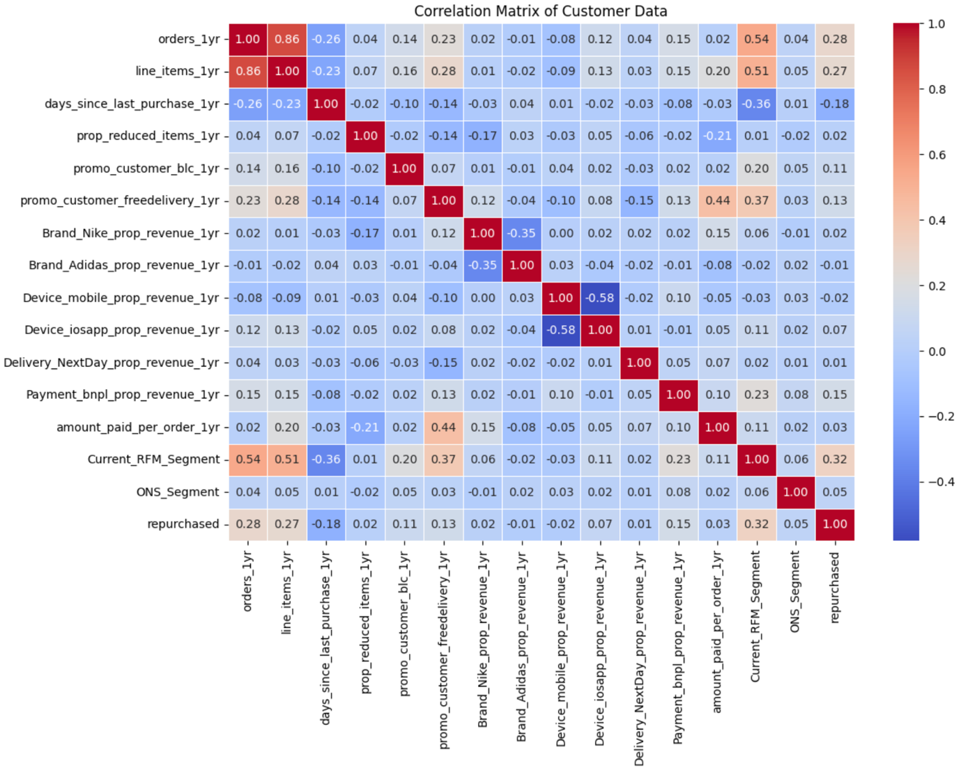

Use Pearson correlation heatmap to examine the linear relationships between the features in your dataset. The heatmap visually represents how strongly pairs of features are correlated, with values ranging from -1 (strong negative correlation) to 1 (strong positive correlation).

Specifically, focused on the "repurchased" variable, which indicates whether a customer made a repeat purchase. Key insights from the heatmap include a strong positive correlation between "repurchased" and "Current_RFM_Segment", as well as "orders_1yr" and line_item_1yr. These features appear to have a more significant relationship with customer repurchasing behavior, providing valuable insights for predicting future customer activity.

To better understand why "Current_RFM_Segment" is the most influential feature in predicting repurchases, we use histrogram along with pie chart that breaks down repurchase behaviour by customer segment.
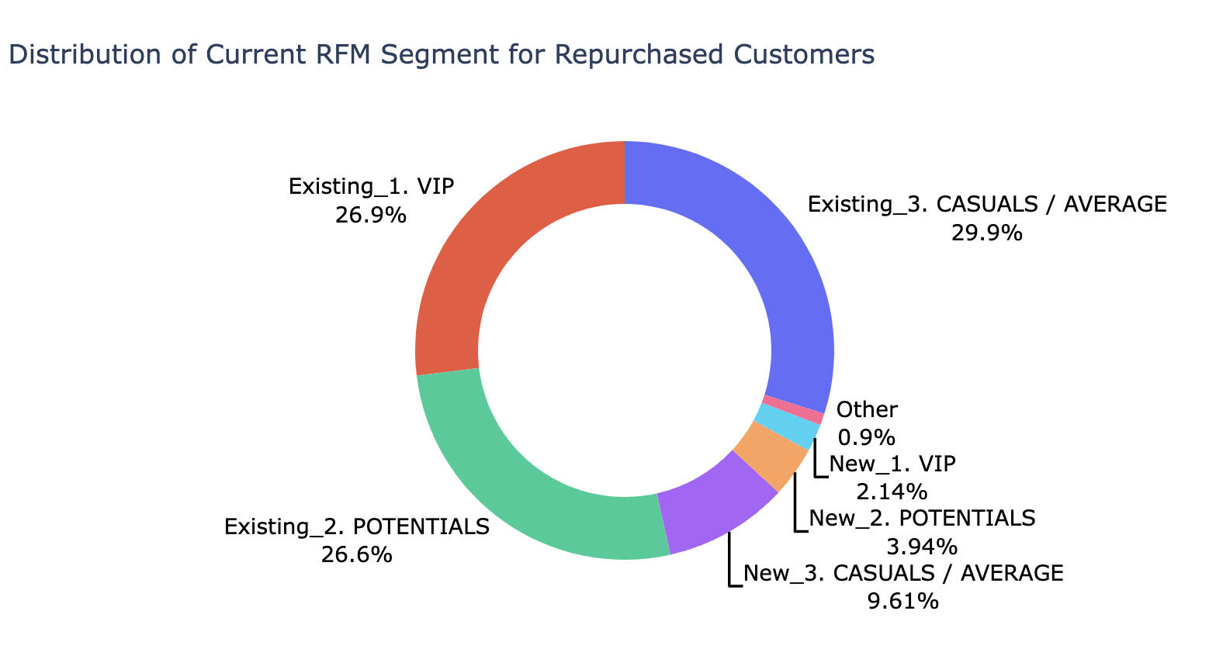

The results reveal that existing customers have the highest probability of making repeat purchases within the next 3 months. Notably, the casual/average customers segment represents the largest share of repeat buyers, indicating that this group is highly engaged and likely to make subsequent purchases. Additionally, the new customers segment shows significant potential, with a strong likelihood of repurchasing shortly after their initial transaction. This analysis highlights the importance of nurturing relationships with both established and new customers to drive future sales.

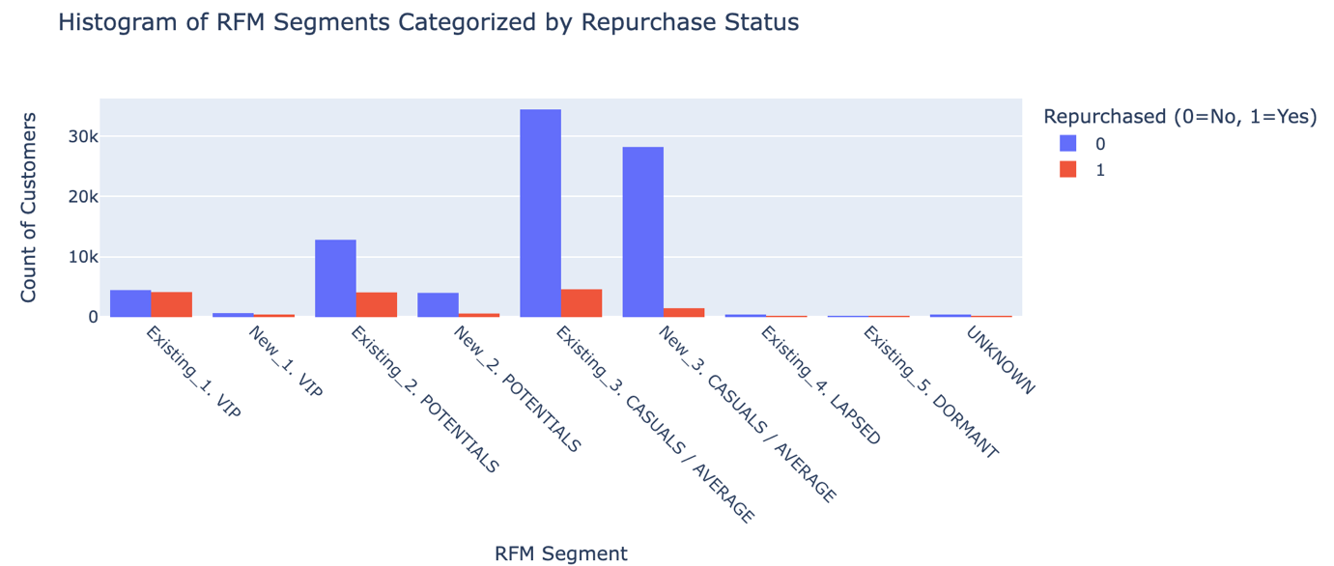

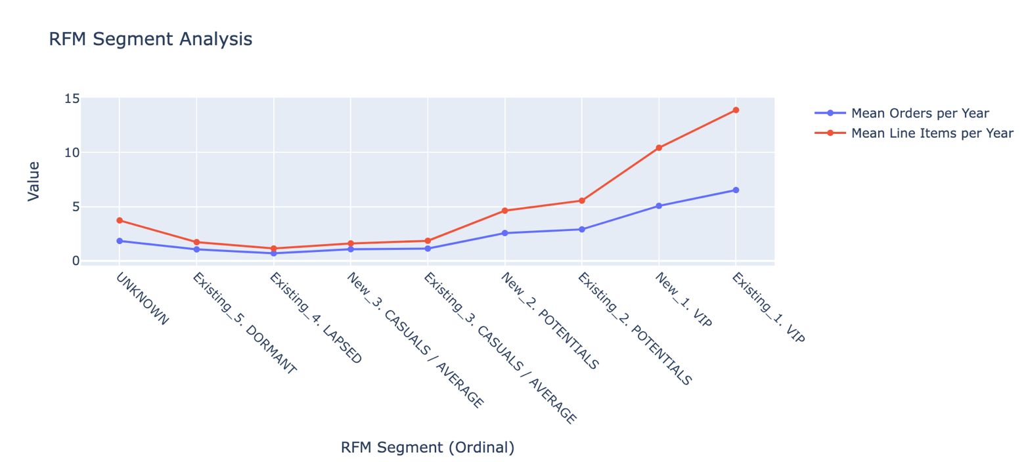

The average line graph for both orders per year and line items per year highlights some interesting trends across customer segments. Notably, the Existing and New VIP groups stand out, placing an average of 10 orders per year and purchasing more than 5 items annually.

Interestingly, the Potential group records a higher average number of orders compared to Casual customers, while the Casual, Lapsed, and Dormant segments exhibit the lowest order and purchase activity throughout the year. There is also a segment of customers classified as "unknown," which cannot be clearly identified, possibly due to data limitations or unclassified behavior.

Both metrics (orders and line items) exhibit a strong positive relationship: customers who place more orders tend to purchase a higher number of items. This suggests that order frequency is closely tied to the total number of items purchased, reinforcing the link between customer activity and engagement.

Model training

We use a machine learning model to identify customers who are most likely to repurchase within the next 3 months. This is a classification task to predict a 1 for customers who are expected to repurchase and a 0 for those who are not, helping the CRM team target our email campaigns more effectively.

Model | 0 (Not repurchase) |  | 1 (repurchase) |  | Training time | Overall Accuracy
Model | Precision | Recall | Precision | Recall | Training time | Overall Accuracy
Baseline models without optimising hyperparameters and remove features
Decision Tree | 0.88 | 0.85 | 0.28 | 0.32 | 372 ms | 0.77
Random Forest | 0.87 | 0.98 | 0.59 | 0.19 | 5.57 s | 0.86
XGBoost | 0.87 | 0.98 | 0.59 | 0.18 | 983 ms | 0.86
Discard uncorrelated features from the dataset
XGBoost  (Remove Features) | 0.87 | 0.98 | 0.60 | 0.16 | 778 ms | 0.86
Adjust parameter to solve the unbalance class problem lead over fitted model
XGBoost  (Remove Features) | 0.91 | 0.75 | 0.30 | 0.60 | 285 ms | 0.73
Fine-tunning model using Grid search to search the most optimal set of parameters
XGBoost  (Remove Features) | 0.91 | 0.81 | 0.34 | 0.55 | 59min 2s | 0.77

- In summary, while both Random Forest and XGBoost Baseline offer similar overall accuracy, XGBoost provides a faster training time we select this model as selected model to improve the model by optimising the hyperparameter and

- Drop features down to 4 main features ['orders_1yr', 'line_items_1yr', 'days_since_last_purchase_1yr', 'Current_RFM_Segment'] still preserve the similar accuracy like using the rest to train the model.

- To handle imbalanced datasets in XGBoost model, we can use several strategies to avoid the model from over-predicting the majority class. One common approach is to use the scale_pos_weight parameter, which helps balance the weight of the minority class relative to the majority class. Here's how you can adjust the model to handle imbalance

- Finally, We are using GridSearchCV to explore all possible combinations of hyperparameters in XGBoost, aiming to identify the most optimal set of parameters that will maximize the model's performance and accuracy.

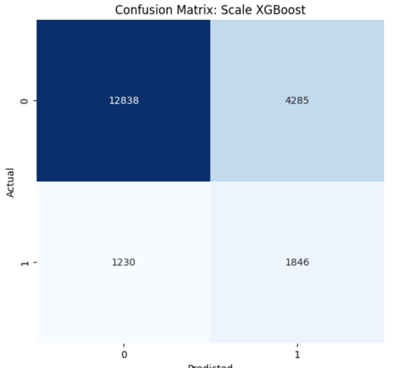
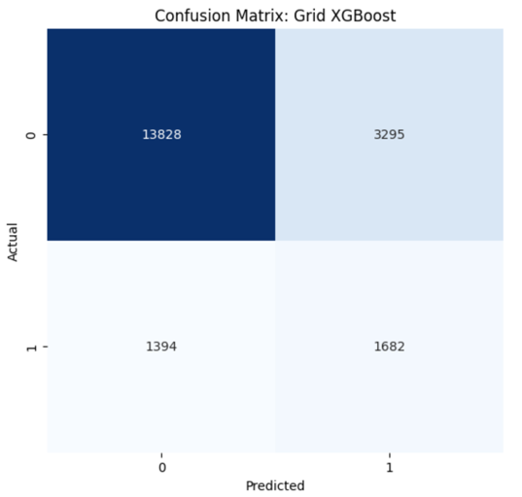
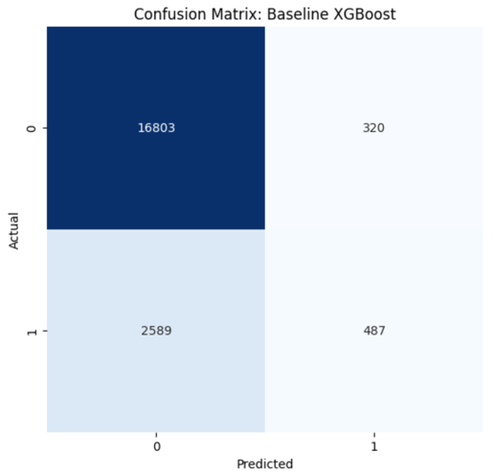

model | TN | FN | TP | FP | Total email sends | Total cost | Misclassification  cost
XGBoost-Baseline | 16803 | 2589 | 487 | 320 | 807 | 1614 £ | 640 £
XGBoost-Scale | 12838 | 1230 | 1846 | 4285 | 6131 | 12262 £ | 8570 £
XGBoost-Grid-search | 13828 | 1349 | 1682 | 3295 | 4977 | 9954 £ | 6590 £
 |  |  | Send the email to correct target | Send the email to incorrect target (misclassification)

To determine the best model from the table, we need to balance both minimizing misclassification cost (FP) and maximizing the number of True Positives (TP)

XGBoost-Baseline: Misclassification Cost per TP= 640 £/ 487​ ≈ 1.31 £/TP
XGBoost-Scale: Misclassification Cost per TP= 8570 £/ 1846​ ≈ 4.64 £/TP
XGBoost-Grid-search: Misclassification Cost per TP= 6590 £/ 1682 ​≈ 3.92 £/TP

Conclusion:
- If minimizing misclassification cost per TP is your primary goal, then XGBoost-Baseline is the best choice.
- If achieving the highest number of True Positives is more important, XGBoost-Scale is preferable despite its higher misclassification cost per TP.

